Minimalist Recipe

sharing App

Team Members:

Ragavi R

Prasanthi R

Pavithira R.S

Varsha R

Swathi S

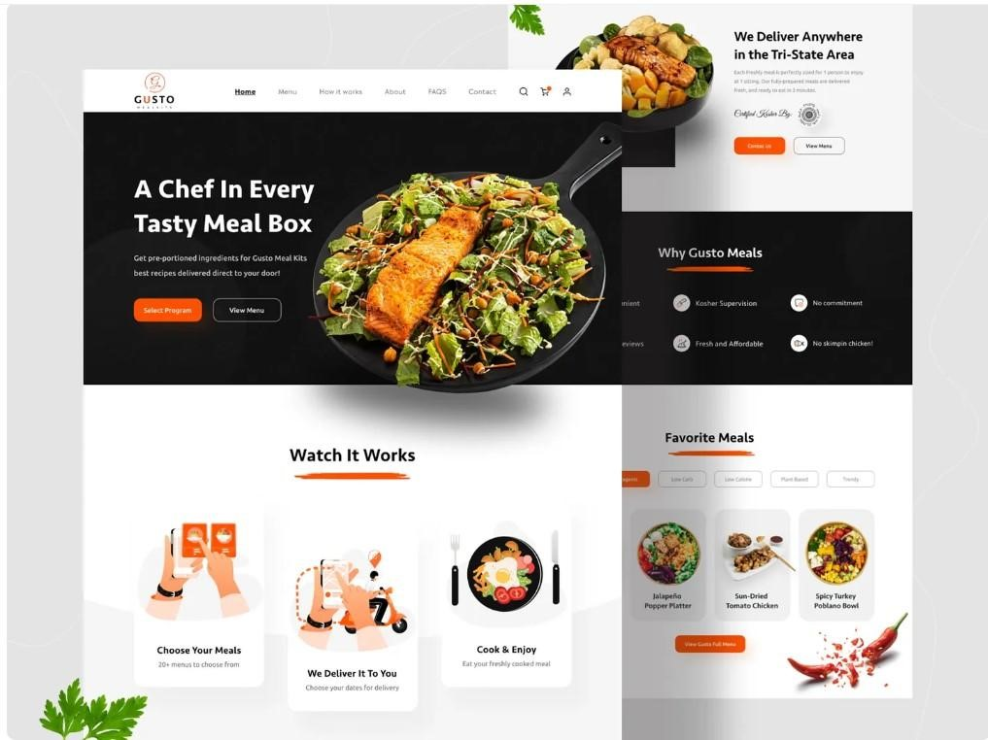

Problem Statement

In today’s digital world, cooking enthusiasts rely heavily on mobile apps and websites to find and share recipes. However, most existing recipe-sharing platforms are cluttered with advertisements, pop-ups, excessive features, and confusing layouts that overwhelm users. This cluttered experience distracts from the main purpose — **discovering and sharing recipes easily and enjoyably**.

Users often struggle to quickly locate simple recipes, follow clear instructions, or upload their own creations without being interrupted by unnecessary content. Additionally, many apps lack a clean, organized interface that promotes focus, creativity, and community connection.



Objectives

●

Create a

**distraction-free platform**

for discovering and sharing recipes.

●

Encourage

**community engagement**

through likes, comments, and minimalistic

user profiles.

●

Support

**easy recipe uploads**

with clean formatting and beautiful presentation.

●

Allow users to

**save favorite recipes**

and organize them by meal type or dietary

preference.



User Interview Questions

notes

Would you like to share your

own recipes with others?

Users want

**clean, ad-free**

**recipe browsing**

.

They value

**trustworthy**

**community content**

over

brand promotions.

Many prefer apps that focus only

on

**recipes**

, not unrelated

features.

**Offline viewing**

and

**quick**

**filtering**

(by ingredients, diet, or

time) are highly desired.

Would you like the app to suggest

recipes based on the ingredients

you already have at home?



User Interview Question

notes

How do you usually find

new recipes?

What frustrates you most

about current cooking or

recipe apps?

Do you prefer step-by-step

visuals, videos, or text-based

recipes?

How important is simplicity

and visual appeal when

following a recipe?



User Persona

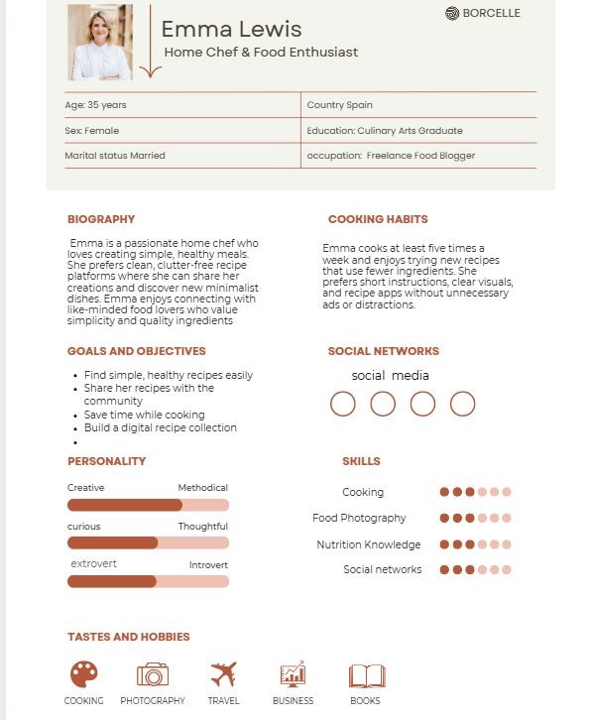

User Persona

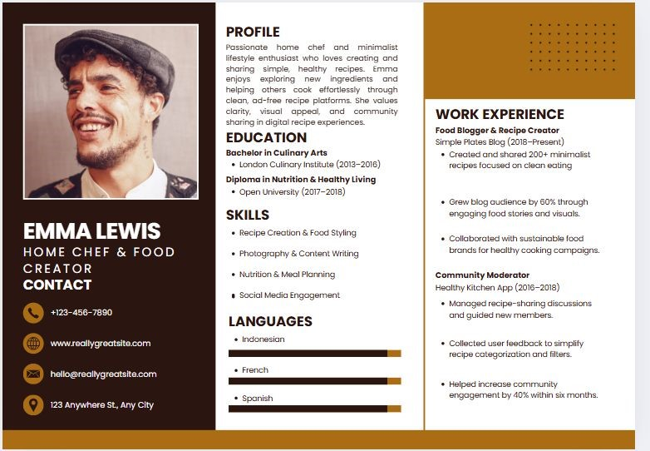

Competitive Analysis

Take way

App Name

Key Features

Pros

Cons

Tasty

Video-based

recipes,

step-by-step guides

Fun interface, visual

learning

Too many ads, not

minimalist

**Yummly**

Smart

recommendations,

ingredient filters

Personalized

suggestions

Overly complex

interface

**AllRecipes**

Large recipe

database, ratings

Community-driven

Outdated design

**Pinterest**

Visual inspiration,

sharing boards

Wide reach,

aesthetic

Not focused purely

on recipes

**Whisk**

Save & organize

recipes, meal

planner

Clean design, easy

sharing

Some features

behind sign-in



Flow Chart

Take way

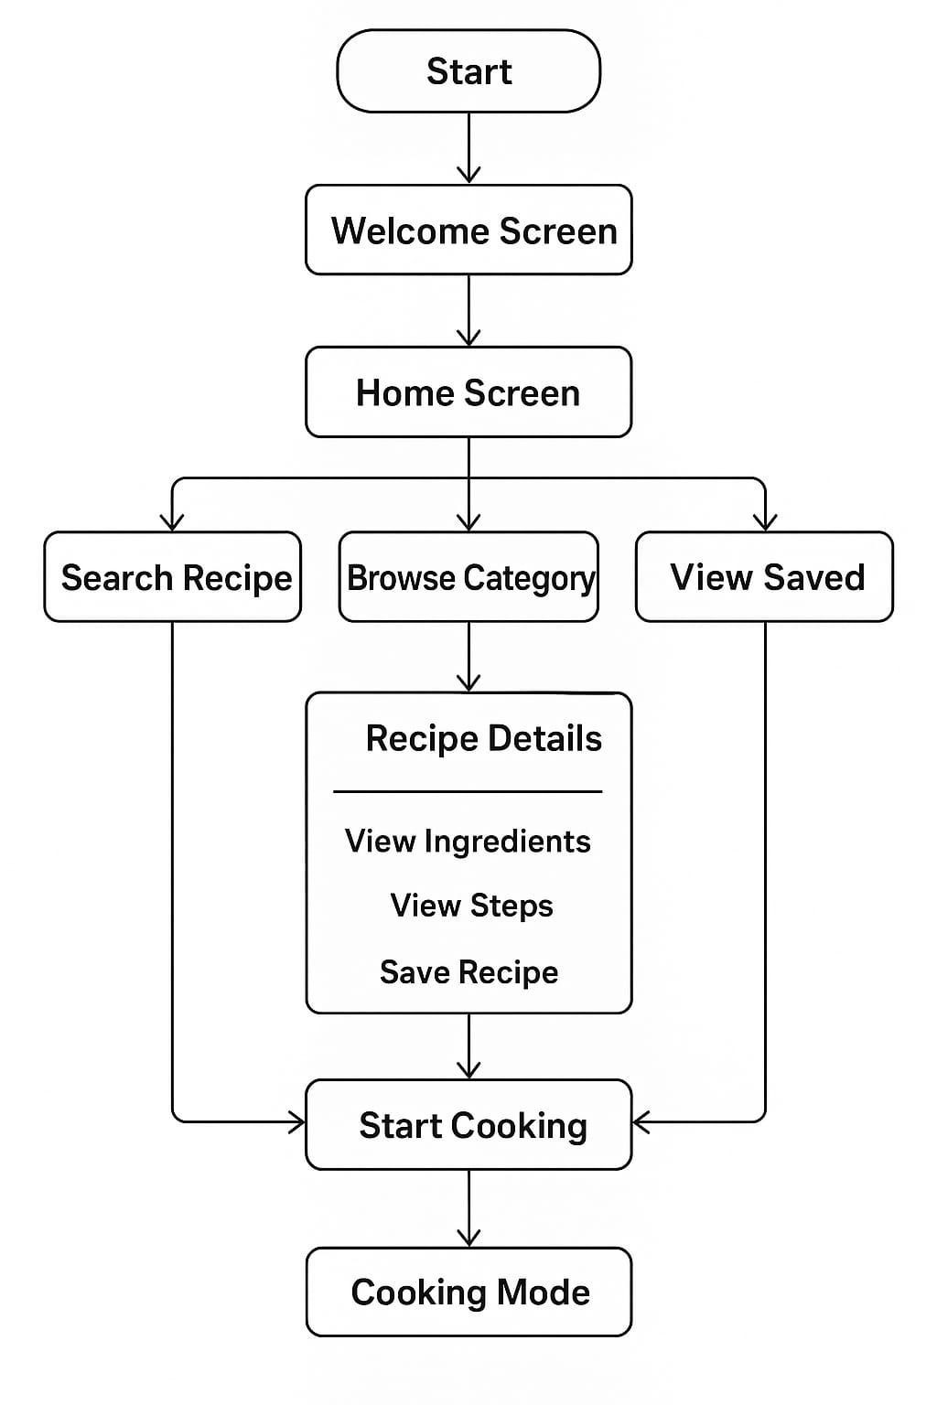

Google stitch

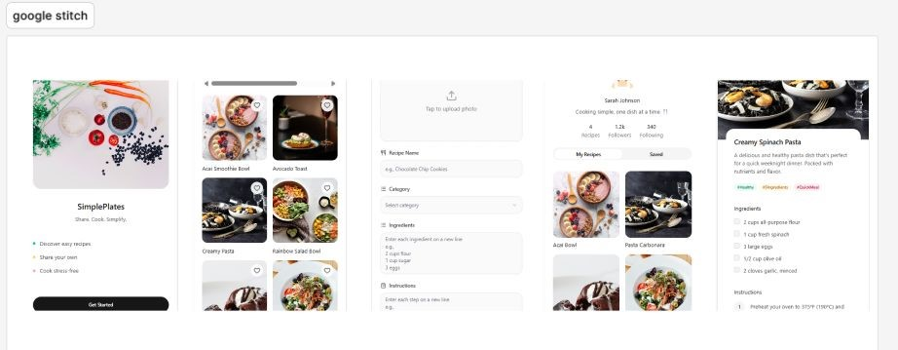

Figma Make

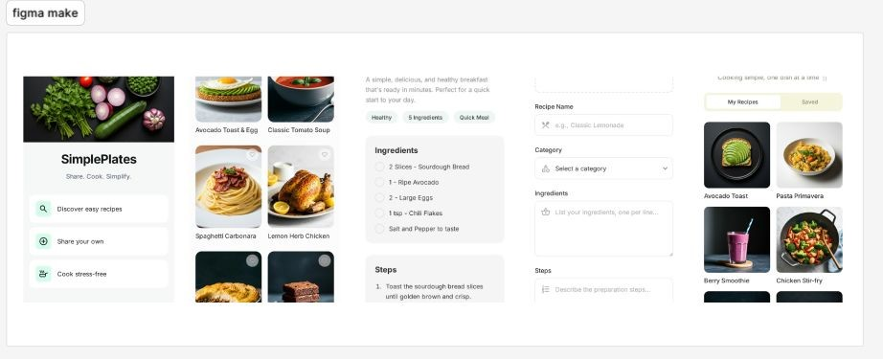

Competitive Analysis-1

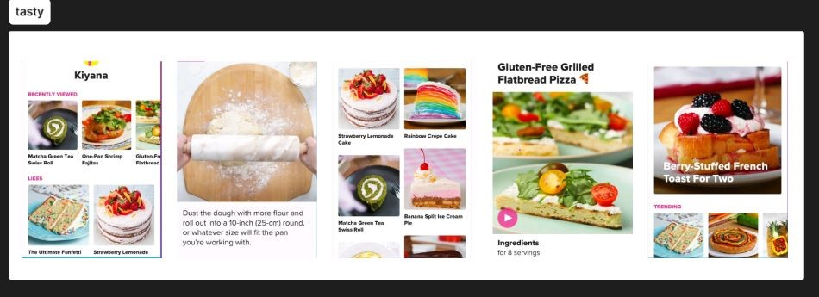

Competitive Analysis-2

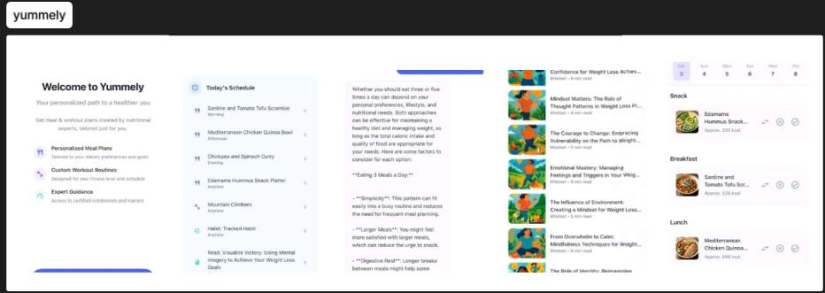

Competitive Analysis-3

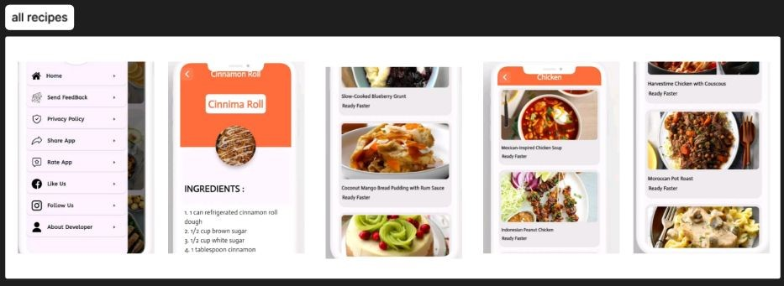

Prototype Link

Google stitch:

https://www.figma.com/proto/nP9Y3FH2XIlUnZqhKr6P29/Untitled?node-id=0-1&p

=

f&t=hN6Bc09AsqY3xphl-0&scaling=scale-down&content-scaling=fixed&starting-p

oint-node-id=1%3A2

Figma Make:

https://www.figma.com/proto/PG2gdNZ7uqseZDrx1w9a1q/Untitled?node-id=0-1&

p=f&t=hN6Bc09AsqY3xphl-0&scaling=scale-down&content-scaling=fixed&starting-

point-node-id=1%3A2